An assessment of wearable electric generators as a source of alternative energy

Table of Contents

An assessment of wearable electric generators as a source of alternative energy 4

Abstract 4

Introduction 5

Literature Review 6

Triboelectric Nanogenerator: Shoe insole 7

Triboelectric Nanogenerator: Corrugated textile 8

Thermoelectric Generator: Flexible foil 9

Thermoelectric Generator: Silk fabric-based 11

Piezoelectric Generator: Nanowire textile 12

Triboelectric–Electromagnetic: A hybrid that works 13

Conclusion 14

Recommendation 15

Literature Cited 16

Table of Figures

Figure 1 Normalized data for battery production (to produce 100kg) 6

Figure 2 A triboelectric-powered cellphone 7

Figure 3 Composition of the TENG 7

Figure 4 The triboelectric series 7

Figure 5 The structure of the corrugated textile based TENG 8

Figure 6 Illustration of the working principle of generating electricity 8

Figure 7 Voltage and current of CT-TENG under different forms of motion 9

Figure 8 A demonstration of the Flexible Foil TEG 9

Figure 9 The n- and p-type materials 10

Figure 10 Resistance vs bending radius, where R0 and R are the residences before and after bending. 10

Figure 11 Structure of the TEG 11

Figure 12 A tube with a PZT textile nanogenerator 12

Figure 13 The process of piezoelectrification 12

Figure 14 Structure of the hybrid WHPG 13

Figure 15 The power output of WPHG 14

*Review*

# An assessment of wearable electric generators as a source of alternative energy

Abstract

: Averagely since about the age of two, human bodies continue to generate noteworthy amounts of energy that impart into the environment unharnessed. In this paper, an evaluation of the current progress in actually harvesting this dissipated energy and converting it into a usable form is done. In dissecting this progress, a group of different generators was researched, giving a diverse, suitable-for-various-environments-and-body-parts abundance of results. Some of the factors found to be considered during the designing process were the end-user’s comfort, the power output, and the price of the unit. The most notable creations that managed, in part or entirely, to combine those design choices successfully were the piezoelectric generators, triboelectric generators, and thermoelectric generators. The piezoelectric generator works on turning the continually changing pressures at the different points of the human body into usable, storable electricity. The thermoelectric generator works on transforming the difference in temperature of the human body relative to ambient temperature into a force that derives electrons around a circuit, essentially creating electricity. On the other hand, the triboelectric generator works on harnessing some sort of static electricity present on the two opposing materials, such as the human body and another material. Authors were able to form those generators into different configurations, ranging from textiles (making wearable clothes-generators) to slaps present only at the joints (where most movement is found). Remarkably, they were able to create products that could produce power ranging from 5 µW to 10 W. The different achievements comprised different levels of usability and function, represented in devices that power wearable instruments such as watches and sensors, and in chargers that power batteries, capacitors, and even cellphones. However, the one thing they agreed on is that they all pointed to one dictum: wearable generators represent a credible solution to the problem of alternative energy.

**Keywords:** piezoelectricity, thermoelectricity, triboelectricity, wearable generators

## Introduction

An axiom of life, energy is conserved, a thing much discussed in *ME.2.04*. (Khurmi, 2006) So, the world needed to look further than solar energy, wind power, and hydropower (both of which are powered by a dc/ac generator, a concept learned in *PH.2.10*) if it hoped to find new sources of energy to better compete with the energy crisis threatening the sustainable development of modern society. (Walker et al., 2014) Most notable of those crises is global warming, a precursor to the excessive burning of fossil fuel and whose effects are conversed thoroughly in *CH.2.11*. (Zumdahl et al., 2014) However, the world did not need to look past its own inhabitants’ body to find a possible contender for solving such a crisis. Additional research in the field of flexible and wearable electronics prompted the scientific interest in finding body-attachable, foldable electric generators to power (a concept discussed at great length in *ME.2.05*) such devices. (Bae et al., 2011; Khurmi, 2006; Zeng et al., 2014) In doing so, researchers paved the way to pivot from the excessive usage of batteries and their supplementary environmental effects, which are illustrated in Figure 1. (McManus, 2012) This transportable, green supply of energy should play an essential role concerning global energy problems. With that in mind, research in the field of self-powered wearable electronics that harvest energy from the ambient environment should be crucial in order to solve the problems relating to energy conservation and pollution control. (Kim et al., 2014) So, the question needed to be answered is as follows: can the human body achieve such feat—provide enough energy to power wearable electronics, and, in conglomerates where much movement is present such as factories, for national usage?

Of note are the two different forms of energy surrounding the human body: mechanical (in the form of vibrations and mechanical friction) and heat energies, both of which, in most cases, get wasted, similar to water falling from uphill having much kinetic energy (as was learned in *ES.2.06*) in that humanity does not benefit from by turning this energy into another form. (Benbow et al., 2016) Recently, however, with the advent of piezoelectric, thermoelectric, and triboelectric generators, there became a way to make use of such water. (Fan et al., 2012; Zhu, Lin, et al., 2013) Most notable of those are discussed next. Wu et al. created a piezoelectric material that is formed into fibres capable of harnessing the energy in the body’s motion. (Wu et al., 2012) Lu et al., however, made a thermoelectric fibre, of power output reaching 15nW at a temperature difference of 20 K. (Lu et al., 2016) In the triboelectric realm, Choi et al. created a textile-based triboelectric generator to harness electrostatic charge. (Choi et al., 2017)

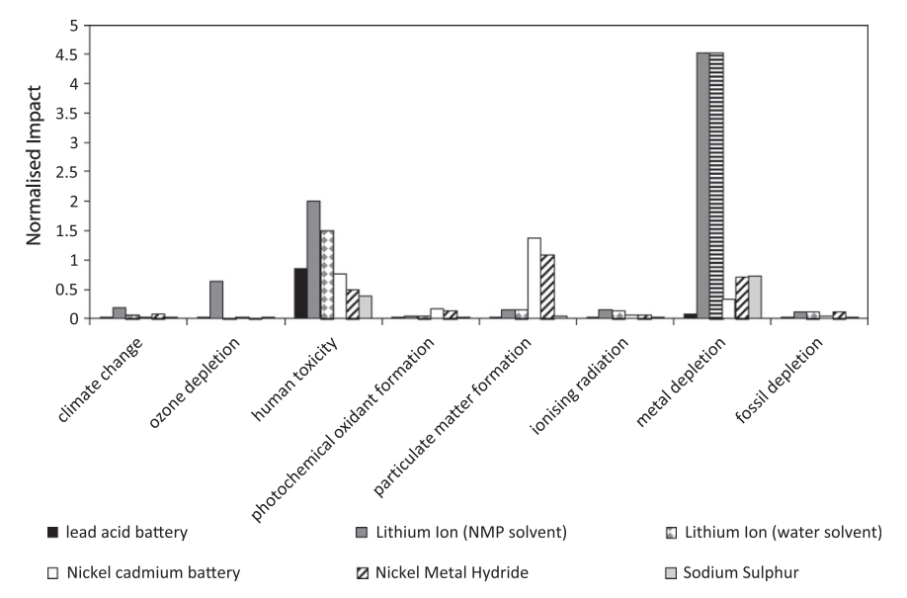

Figure 1 Normalized data for battery production (to produce 100kg)

In the rest of the paper, a discussion about what each mechanism brings to the table is made, comparing two implementing the same category and clearing what each one does right and wrong.

## Literature Review

The possibility of wearable generators having an answer to the issue of the global energy crisis is intriguing. With each solution differing in mechanism from the other, it may seem hard to find a definitive answer. So, in the next paragraphs, each mechanism will be discussed by comparing them and clearing what each one solves individually, and sometimes presented solely for their merit.

### Triboelectric Nanogenerator: Shoe insole

Zhu et al. propose a triboelectric generator that is a replacement for regular shoe soles. (Zhu, Bai, et al., 2013) The authors’ accomplishment resulted in a generator producing enough power (a concept discussed at great length in *ME.2.05*) to charge a cellphone, as shown in Figure 2. (Khurmi, 2006)

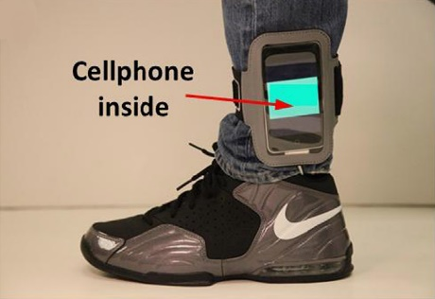

Figure 2 A triboelectric-powered cellphone

#### Structure

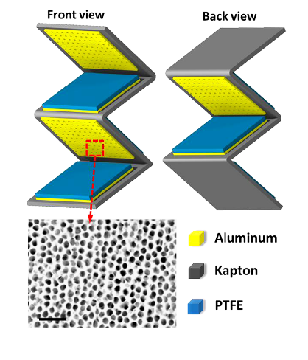

Figure 3 Composition of the TENG

. Each shoe sole is fabricated by composing three layers of TENG, each layer is composed of stacked porous aluminium (porous so as to increase surface area), PTFE, and Kapton, as shown in Figure 3. The aluminium stack of the three layers is connected in parallel to form a single electrode, while the other electrode is copper prepared at the back of the PTFE film.

#### Mechanism

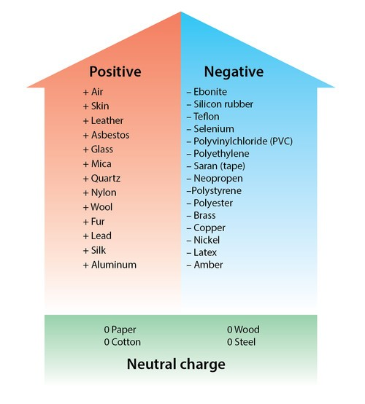

Figure 4 The triboelectric series

. Under pressure exerted by the human body, electrostatic induction between the aluminium layer and the PTFT layer dictates that an electron transfer between the two materials happen, as explained by the triboelectric series (shown in Figure 4). When the pressure is released, the now two dipolic surfaces (Al and PTFT) induce charges on the electrode, inducing an electric current. The idea of induction is discussed thoroughly in *PH.2.02*. (Walker et al., 2014)

#### Strengths and weaknesses

. The sole-based TENG enjoys a power output at 50-60 kPa (comparable to a step) reaching 132 mW, specifically 600 µA of short-circuit current and over 220 V of open-circuit voltage. Their compact design and usage of three layers of TENG connected in parallel all contributed to this increase, bearing in mind the materials that were used, which can be considered a weakness, where they were not far from each other on the triboelectric series that their effect was weak. Moreover, the limited usage as a foot sole is comparably modest, relative to other creations, as discussed next.

### Triboelectric Nanogenerator: Corrugated textile

Choi et al.’s creation, compared to the previous authors’, can be considered more versatile. (Choi et al., 2017) The authors created a corrugated textile that does not only generate electricity from rubbing or pressing but also from stretching.

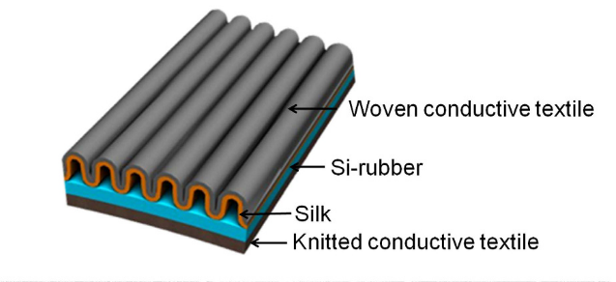

Figure 5 The structure of the corrugated textile based TENG

#### Structure

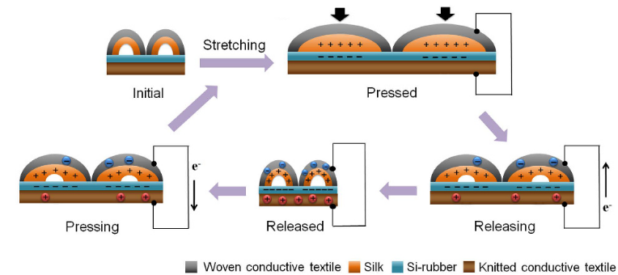

Figure 6 Illustration of the working principle of generating electricity

. The CT-TENG is composed of two wrapping layers: silk with an attached conductive textile on the top and silicone rubber with knitted conductive textile on the bottom (see Figure 5).

#### Mechanism

. The working mechanism is illustrated in Figure 6. It works on the same principle as the previous author’s creation, only the two contacting materials are different.

#### Strengths and weaknesses

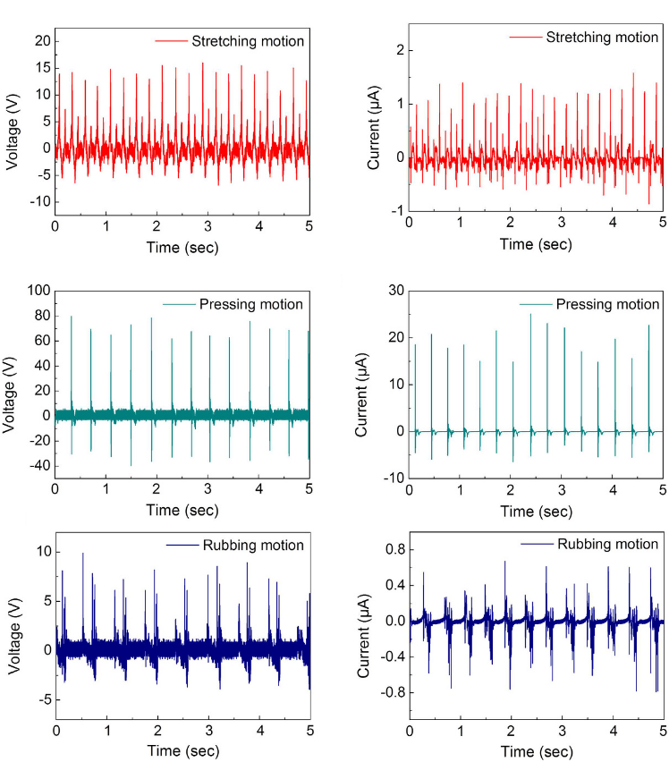

Figure 7 Voltage and current of CT-TENG under different forms of motion

. The achievement versatile in use. It can harness electricity from the different moving body parts, namely the wrist, knee, and foot. The power output under three distinct modes of generation is shown in Figure 7, attesting to high power output (not very high nonetheless). (The current had to be rectified using a diode in order to be unidirectional; the concept of rectification was conversed methodically in *PH.2.15*, so debt to it is credibly paid. (Walker et al., 2014)) On the weaknesses side, sweating and washing are not permissible: absorbent. Moreover, compared to the previous authors’ creation, the power output is low. This is, again, due to the materials being not very far from each other in the triboelectric series, and also due to the ineffectiveness of motion at those body regions.

### Thermoelectric Generator: Flexible foil

Wan et al. propose, in opposition to solid slate regular TEGs, a flexible foil that is capable of achieving the same function: turning temperature difference into electricity. (Wan et al., 2016) With that, the authors brought the possibility of a TEG being fairly bendable with the human body (depicted in Figure 8).

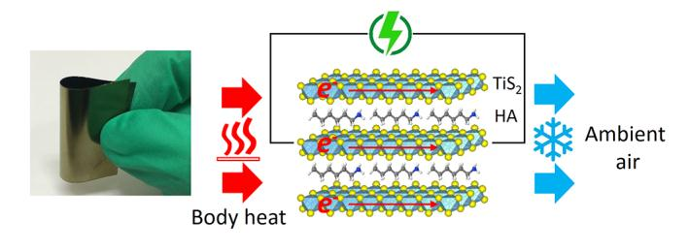

Figure 8 A demonstration of the Flexible Foil TEG

#### Structure

. The flexible foil is made by composing two hybrid superlattices of TiS2 layers and hexylamine molecules. This is achieved by having electrons transfer from the hexylamine molecule to the TiS2 (through a Lewis base-acid reaction, an idea much important in *CH.2.03*), creating an n-type material, i.e., a material having an excess number of electrons. (Zumdahl et al., 2014)

#### Mechanism

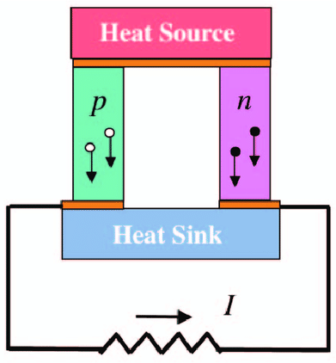

Figure 9 The n- and p-type materials

. When a source of heat (the human body in this case) is applied to one side of the foil, charges migrate away from it. At the p-type material, the charge is a positive one, signified by the absence of an electron, contrasting the n-type material, where an electron is present instead (this structure is illustrated in Figure 9). The concept of PN junctions is discussed with much length at *PH.2.15*. (Walker et al., 2014) This movement creates a flow of current. The phenomenon is governed by the Seebeck effect, obeying the equation $V_{(thermo emf)}= αθ+ \frac{1}{2}βθ^{2}$, where the θ is the temperature difference, and α and β are constants depending on the nature of the materials.

#### Strengths and weaknesses

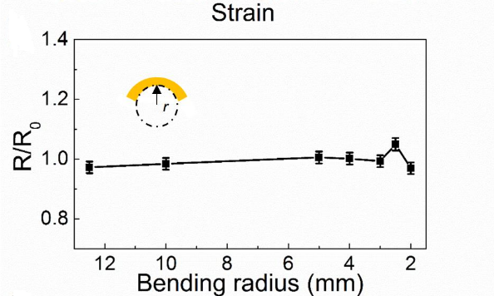

Figure 10 Resistance vs bending radius, where R0 and R are the residences before and after bending.

. A repercussive advantage in using a thermoelectric material is that packaged with it is the Peltier effect. If the unit is provided with electricity, it results in having a cooler side and a hotter side, effectively the reverse function. So, instead of wasting large amounts of energy on heating or cooling inanimate objects using central heating in buildings, a person can have a smart personal thermal manager. That aside, the authors’ creation achieved a groundbreaking feat by their bending material that retains its resistance at a constant level even at smaller bending radii (see Figure 10). Nonetheless, the prototype does have some weaknesses. Although the bending range is relatively large, it may not fit some movements of humans’ bodies. It may strain and become nonfunctional prematurely with excessive usage. Moreover, mass production is unviable to this creation: for now, it requires a set of steps doable by a human hand in a laboratory. Next, another solution tackling those issues will be discussed.

### Thermoelectric Generator: Silk fabric-based

Lu et al. developed the Thermoelectric (TE) power generators to harvest energy from the human body as a technique of wearable technology. (Lu et al., 2016) The authors have succeeded in using the TE material, bismuth telluride (Bi2Te3) and antimony telluride (Sb2Te3) in the silk fabric from Bombyx mori cocoons which is considered as “the queen of textiles.” They clarified that this fabric of silk had been highly praised by the TE developer because of the difficulty of making the TE as much flexible as the silk fabric.

#### Structure

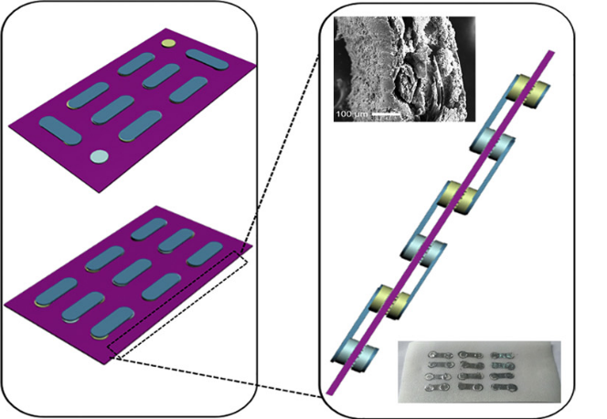

Figure 11 Structure of the TEG

. The silk-based TE power generator consists of silk fabric within a layer of polyvinyl alcohol. Each of the opposite sides of the silk fabric has 12 TE material coulombs (consisting of 80 mg Bi2Te3 or 120 mg Sb2Te3), liquid adhesive binder, and deionized water. Silver foils are pasted onto the TE column to assure the viability Seebeck effect with p-type and n-type. The final structure is shown in Figure 11.

#### Mechanism

. While exercising, the temperature of the human body increases relative to the surrounded environment. The mechanism similar to the one discussed before, only the used materials differ.

#### Strengths and weaknesses

. In this silk-based TE generator, the materials used are the Bi and Sb elements, which are far apart on the thermoelectric series; therefore, the power generated is efficient. Moreover, it enjoys very high stress and strain shelf-age. However, the silk-based TE generator has a power and voltage output of 15 nW and 10 mV, respectively, which can be considered a weakness; but storable in a lithium-ion battery.

### Piezoelectric Generator: Nanowire textile

Wu et al. transformed the regular solid-state piezoelectric generators into a nanowire textile that is more malleable and usable around a human body. (Wu et al., 2012) In opposition to the problems faced during the fabrication process of similar nanowires holding a high piezoelectric coefficient, the authors innovated a method by which they succeeded in achieving their desired outcome: a flexible, dense, tough, and uncostly nanowire that can be wrapped with an organic material creating a textile (see Figure 12).

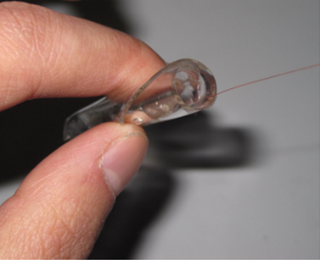

Figure 12 A tube with a PZT textile nanogenerator

#### Structure

. The structure of the piezoelectric generator is a lead zirconate titanate textile where the nanowires are laid out parallel with each other. The nanowires are then attached to the PDMS layer, resulting in the wearable nanogenerator shown above.

#### Mechanism

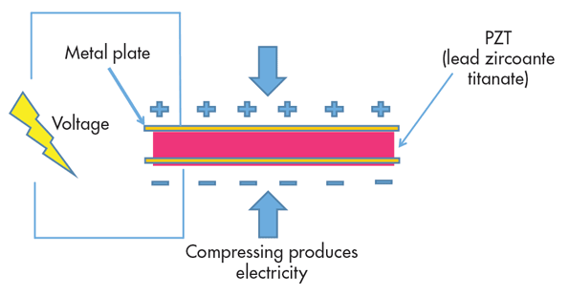

Figure 13 The process of piezoelectrification

. For some materials, collectively called the “Piezoelectric material,” when stress or tension is applied to one side of crystal composed of such material, a potential difference across the two sides appear, a process illustrated in the opposite Figure 13, generating usable electricity. The power output of such a device can be calculated using the equation $P_{l}= \frac{1}{T}\int{\frac{U^{2}(t)}{R_{l}}dt}$, where *U(t)* is real-time voltage, Rl is the load resistance, and T is the period of load application. MA.2.09 was of much help in understanding such an equation. In the case of the wearable piezoelectric generator, the tension or stress comes from the everyday movement of a human body.

#### Strengths and weaknesses

. First, piezoelectric transduction is an always-present force relative to thermoelectricity in that the ambient vibrations are continuous and do not rely on environmental conditions. Also, piezoelectric generators possess an advantage over other methods of being a wearable generator that keeps the same efficiency as scale is reduced, inherent transduction capacity, and higher power density. Weaknesses points of piezoelectric generators are the limited working temperature as high temperature causes instability and depolarization. Furthermore, the brittleness of the generator is an important weakness as shocks can damage the generator.

### Triboelectric–Electromagnetic: A hybrid that works

Guo et al. formulated their answer to the problem of alternative energy by creating a hybrid generator that utilizes both the triboelectric and electromagnetic phenomena. (Guo et al., 2016) The author’s solution is not specifically tailored towards wearable generators but solves some problems previous related to them. While TENGs are efficient enough, the way of their packaging prevents the transfer of motion in the ambient environment like vibration or water waves. The author’s fixed that using by adding electromagnetic generators (EMG).

#### Structure

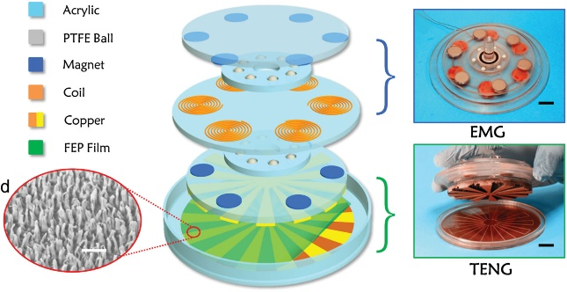

Figure 14 Structure of the hybrid WHPG

. (Shown in Figure 14.) The prototype consists of both TENG and EMG. Firstly, the TENG is made by having an acrylic sheet deposited within a stator and a rotator (the moveable part), covered by a fluorinated ethylene propylene 50 µm thickness, then connected with nanowires with 100 nm diameter. The second part (EMG) consists of the same acrylic sheet with 6 synclastic twined coils and 6 identical magnets on the other side of the sheet.

#### Mechanism

. The rotators generate equal negative charges on FEP surface and positive charges on the copper surface in the initial state. Then, the FEP and copper surfaces take turns with charges through the external circuit due to the potential difference between the electrodes, preserving the equilibrium state at the intermediate state. Then, it gets induced again at the final state due to magnetic flux. The rotators keep rotating again and again, while the magnetic flux crosses the coil. The rotators hinder the magnetic field, generating a changing in the magnetic flux by harvesting potential difference, as stipulated by Lenz’s Law and Faraday’s Law in *PH.2.08*. (Walker et al., 2014)

#### Strengths and weaknesses

. The WPHG is lightweight and can be embedded in fabrication that allows it to be utilized resourcefully. And it works efficiently even at low rotation speeds. Also, the authors ensure that the outputs reach 2.3 mA in short circuit current and 5 V in open-circuit voltage (more shown in Figure 15). However, to make the WPHG, it requires advanced services and machines, in addition to accurately in the manipulating.

Figure 15 The power output of WPHG

## Conclusion

Humans persisted in domination by adapting to their circumstances, achieved either by expanding their capacity to think and operate or by innovating solutions that helped them do so. Now, against the looming crisis of energy depletion, they are faced with yet another challenge: either find new ways to claim energy from the environment or ways to conserve every ounce of energy they already possess. The first has ongoing research for years, and scientists have reached some impressive conclusions regarding the issue. However, the second does not receive much attention. In this paper, it was shown that simple extensions to the human body could be utilized to power small devices, rendering the excessive usage of polluting batteries less necessary. Furthermore, in aggregation, such devices can be used to generate an immodest amount of electricity that can be used to power much more, working passively without much mind paid to. Of those scientific creations were generators that depended on the piezoelectric, triboelectric, and thermoelectric phenomena, each transformed into a nanogenerator fit to function near a certain human body part. Some focused on compatibility with the human body conditions, some focused on generating as much power as possible, and some focused on being applicable to as many body parts as possible. Even at low frequencies as some humans’ motion is, the generators were able to harness some power from those movements. As a result, it stands to reason that further improvements in this field—by inventing methods for mass-production, finding fitting operating materials (uncostly and comfy)⁠, and finding the right investors—would bring this group of nanogenerators into our everyday life. However, even at the field’s infancy, it is still capable of showing that the dictum is rightly true: wearable generators can act as a source of alternative energy.

## Recommendation

Some important characteristics that any wearable electric generator must follow in the future can be summarized in the following: First, it needs to be waterproof. Sweating and other sources of water should not be able to interfere with the functioning of the wearable generator. Second, it needs to be fairly stretchable. Humans bend in a large number of ways. If the generator cannot keep up with the bending of the human body and breaks easily with excessive bending, it would not be appropriate to be mass-released. Third, in regard to being body attachable, clothes attachable, or clothes textile, it has to have a form of answer to having the ability being cleaned: in the case of

* body attachable, it has to be ‘washable,’
* clothes attachable ‘removable from or washable with the clothes,’ and
* textile ‘washable.’

Another important thing is making the right contracts with the right clothes company for mass-production.

## Literature Cited

Bae, J., Song, M. K., Park, Y. J., Kim, J. M., Liu, M., & Wang, Z. L. (2011). Fiber supercapacitors made of nanowire-fiber hybrid structures for wearable/flexible energy storage. *Angewandte Chemie - International Edition, 50*, 1683-1687. doi:10.1002/anie.201006062

Benbow, A., Carpenter, M., Hoover, M., Smith, M. J., & Southard, J. B. (2016). *EarthComm: project-based space and earth system science* (Second Edition ed.): Its About Time, Inc.

Choi, A. Y., Lee, C. J., Park, J., Kim, D., & Kim, Y. T. (2017). Corrugated Textile based Triboelectric Generator for Wearable Energy Harvesting. *Scientific Reports, 7*, 7-12. doi:10.1038/srep45583

Fan, F.-r., Lin, L., Zhu, G., Wu, W., Zhang, R., & Wang, Z. L. (2012). Transparent Triboelectric Nanogenerators and Self-Powered.pdf. doi:10.1021/nl300988z

Guo, H., Wen, Z., Zi, Y., Yeh, M. H., Wang, J., Zhu, L., . . . Wang, Z. L. (2016). A Water-Proof Triboelectric-Electromagnetic Hybrid Generator for Energy Harvesting in Harsh Environments. *Advanced Energy Materials, 6*, 1-7. doi:10.1002/aenm.201501593

Khurmi, R. S. (2006). *A textbook of engineering mechanics*. India: S. Chand and Company.

Kim, S. J., We, J. H., & Cho, B. J. (2014). A wearable thermoelectric generator fabricated on a glass fabric. *Energy and Environmental Science, 7*, 1959-1965. doi:10.1039/c4ee00242c

Lu, Z., Zhang, H., Mao, C., & Li, C. M. (2016). Silk fabric-based wearable thermoelectric generator for energy harvesting from the human body. *Applied Energy, 164*, 57-63. doi:10.1016/j.apenergy.2015.11.038

McManus, M. C. (2012). Environmental consequences of the use of batteries in low carbon systems: The impact of battery production. *Applied Energy, 93*, 288-295. doi:10.1016/j.apenergy.2011.12.062

Walker, J., Resnick, R., & Halliday, D. (2014). *Halliday & Resnick fundamentals of physics* (10th edition ed.). Hoboken, NJ: Wiley.

Wan, C., Tian, R., Azizi, A. B., Huang, Y., Wei, Q., Sasai, R., . . . Koumoto, K. (2016). Flexible thermoelectric foil for wearable energy harvesting. *Nano Energy, 30*, 840-845. doi:10.1016/j.nanoen.2016.09.011

Wu, W., Bai, S., Yuan, M., Qin, Y., Wang, Z. L., & Jing, T. (2012). Lead zirconate titanate nanowire textile nanogenerator for wearable energy-harvesting and self-powered devices. *ACS Nano, 6*, 6231-6235. doi:10.1021/nn3016585

Zeng, W., Shu, L., Li, Q., Chen, S., Wang, F., & Tao, X. M. (2014). Fiber-based wearable electronics: A review of materials, fabrication, devices, and applications. *Advanced Materials, 26*, 5310-5336. doi:10.1002/adma.201400633

Zhu, G., Bai, P., Chen, J., & Lin Wang, Z. (2013). Power-generating shoe insole based on triboelectric nanogenerators for self-powered consumer electronics. *Nano Energy, 2*, 688-692. doi:10.1016/j.nanoen.2013.08.002

Zhu, G., Lin, Z. H., Jing, Q., Bai, P., Pan, C., Yang, Y., . . . Wang, Z. L. (2013). Toward large-scale energy harvesting by a nanoparticle-enhanced triboelectric nanogenerator. *Nano Letters, 13*, 847-853. doi:10.1021/nl4001053

Zumdahl, S. S., Zumdahl, S. A., & Decoste, D. J. (2014). *Chemistry* (Ninth Edition ed.). Belmont, CA: Brooks/Cole, Cengage Learning.